1.
import numpy as np

a=np.array([2,5,10])

print(a,a.dtype)

B=np.array ([2.4,10.6,5.2])
print(B,B.dtype)

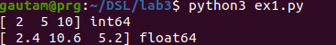
2.
import numpy as np

A=np.array([(3,4,5),(12,6,1)])
Z=np.zeros((2,4))
O=np.ones((3,3))

print(A)
print(Z)
print(O)

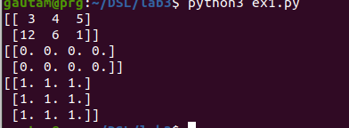
3.
import numpy as np

S=np.arange(10,30,5)
print(S)

A=np.arange(0,2,0.3)
print(A)

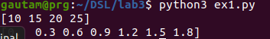
4.
import numpy as np

S1=np.linspace(0,2,9)
print(S1)

5.
import numpy as np
import random as rd

print(rd.choice([1,2,3,4,5]))
print(rd.choice('python'))
print(rd.randrange(25,50))
print(rd.randrange(25,50,2))
print(rd.random())
print(rd.uniform(5,10))
l=[1,2,3,4,5]
rd.shuffle(l)
print(l)

rd.seed(10)
print(rd.random())

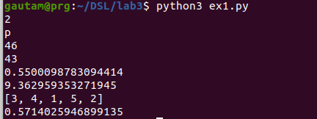
6.
import numpy as np
import random as rd

a=np.arange(15).reshape(3,5)
print(a)
print(a.shape,a.size)
print(a.T)

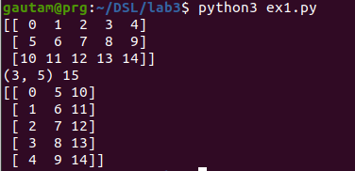
7.

import numpy as np
import random as rd
c=np.arange(24).reshape(2,3,4)
print(c)
print(c.shape)
print(c[1,:,:])
print(c[:,:,2])

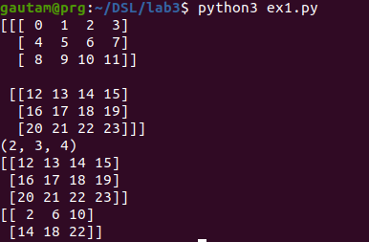
8.
import numpy as np
import random as rd

a=np.array([20,30,40,50])
b=np.arange(4)
print(b)
c=a-b
print(c)
print(b**2)
print(10*np.sin(a))
print(a<35)

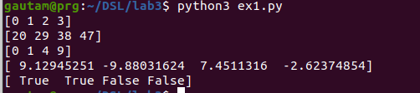
9.
import numpy as np
import random as rd

A=np.array([[1,1],[0,1]])
B=np.array([[2,0],[3,4]])
print(A)
print(B)
print(A*B)
print(np.dot(A,B))

b=np.arange(12).reshape(3,4)
print(b)

print(b.sum(axis=0))
print(b.sum(axis=1))

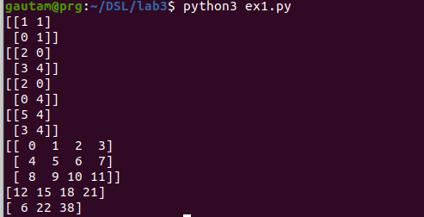
10.
import numpy as np

r=int(input("Give no of rows: "))
c=int(input("Give no of cols: "))

print("Enter elements")
elements=list(map(int,input().split()))
b=np.array(elements).reshape(r,c)
print(b)

print(b[2,3])
print(b[:5,1])
print(b[-1,:])
print(b[:,-1])

for row in b:
print(row)

for element in b.flat:
print(element)

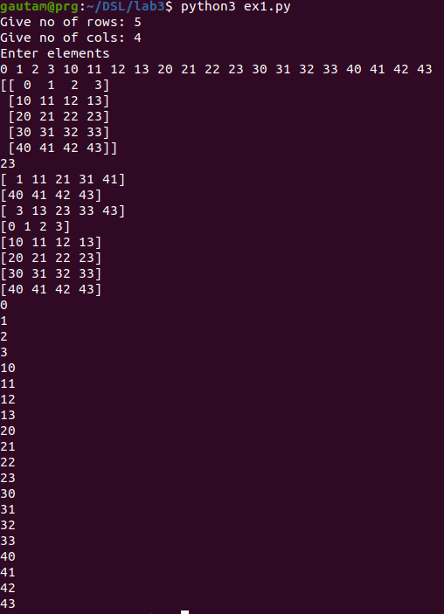
11.
import numpy as np

r=int(input("Give no of rows: "))
c=int(input("Give no of cols: "))

print("Enter elements")
elements=list(map(int,input().split()))
b=np.array(elements).reshape(r,c)
print(b)

print(b.ravel())
B1=b.reshape(4,5)
print(B1)

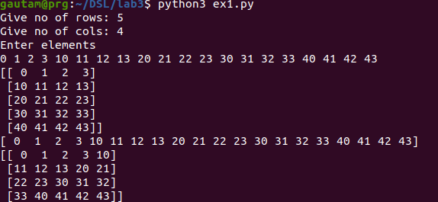
12.

import numpy as np

A1=np.array([(3,4,5),(12,6,1)])
A2=np.array([(1,2,6),(4,3,8)])
D1=np.vstack((A1,A2))
D2=np.hstack((A1,A2))
print(A1)
print(A2)
print(D1)
print(D2)

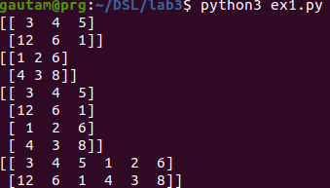
13.

import numpy as np

a=np.array([4.,2.])
b=np.array([3.,8.])

c1=np.column_stack((a,b))
print(c1)

c2=np.hstack((a,b))
print(c2)

c3=np.hstack((a[:2],b[:2]))
print(c3)

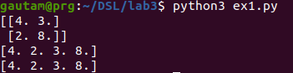
14.
import numpy as np

a = np.arange(12)**2
i = np.array( [ 1,1,3,8,5 ] )
print(a[i])

j=np.array([[3,4],[9,7]])
print(a[j])

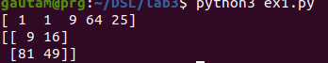
15.

import numpy as np

a=np.array([(3,2,9),(1,6,7)])

s1=0
for row in a:
for col in row:
s1+=col

print(s1)

s=0
for i in range(a.shape[0]):
for j in range(a.shape[1]):
s+=a[i,j]

print(s)

